CRITICAL PATH METHOD

(CEE 320 – VDC SEMINAR)

Jesse Santiago & Desirae Magallon

4 February 2009

Overview

* Background & History
* CPM Defined
* The CPM approach
* Definitions
* Class Exercise

Background & History

* Developed in the 1950s by the US Navy
* Originally, the critical path method considered only logical dependencies between terminal elements
* Since then, it has been expanded to allow for the inclusion of resources related to each activity, through processes called activity-based resource assignments and resource leveling.
* Critical Path Method for the construction industry

☺ Non-computer approach

☺ John Fondahl

John Fondahl

* Stanford CE Professor Emeritus – 35 years
* Passed away last September 13th, 2008
* US Marine Corps Sergeant in Iwo Jima

☺ His father was USMC LtCol

* Co-founder of the CEM program
* 1961 Paper for the US Navy – "Non-Computer

Approach to the Critical Path Method for the Construction Industry"

What is CPM?

The Critical Path Method or Critical Path Analysis, is a mathematically based algorithm for scheduling a set of project activities

It is an important tool for effective project management

Commonly used with all forms of projects, including construction, software development, research projects, product development, engineering, and plant maintenance, among others

Any project with interdependent activities can apply this method of scheduling









What is CPM?

□ The essential technique for using CPM is to construct a model of the project that includes the following:

☺ A list of all activities required to complete the project (also known as Work Breakdown Structure)

☺ The time (duration) that each activity will take to completion

☺ The dependencies between the activities.

What is CPM?

* CPM calculates

☺ The longest path of planned activities to the end of the project

☺ The earliest and latest that each activity can start and finish without making the project longer

* Determines “critical” activities (on the longest path)
* Prioritize activities for the effective management and to shorten the planned critical path of a project by:

☺ Pruning critical path activities

☺ “Fast tracking" (performing more activities in parallel)

☺ “Crashing the critical path" (shortening the durations of critical path activities by adding resources)

The CPM Approach

* Phase I

☺ Break project into operations necessary for completion

☺ Determine sequential relationship of operations

* + Every operation must have event to mark commencement –

i.e. completion of preceding operation

* Can operations overlap?

The CPM Approach

* Phase II

☺ Create **time** estimates for each operation

☺ Determine earliest possible start date, earliest possible finish date , latest start & finish

* + Determine “free float” and “total float”

☺ Revised after completion of Phase III

The CPM Approach

* Phase III

☺ Establish **time-cost** relationship

☺ Establish scheduling variations

* + Determine most favorable balance between time-cost

☺ Normal Start – normal time, least cost

☺ All-Crash Start – least time, higher cost

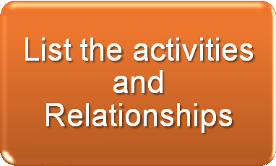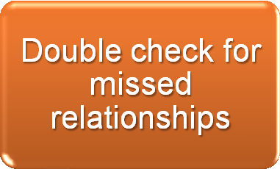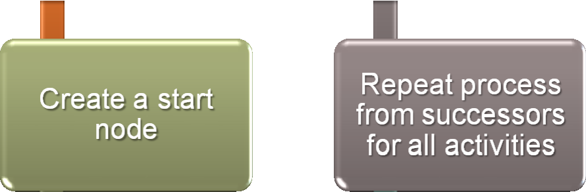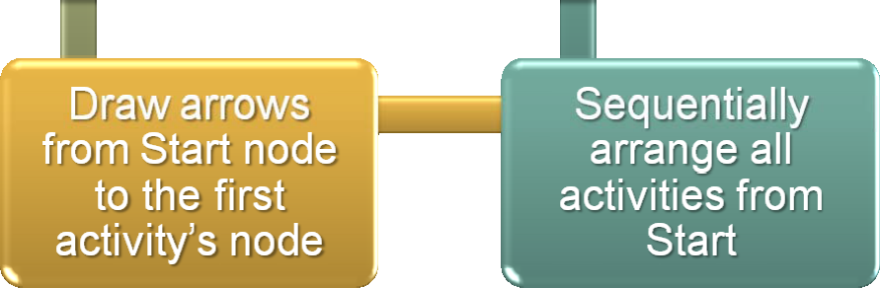

The CPM Approach

Definitions

**Float** (**slack) -** amount of time that a task can be delayed without causing a delay to:

☺ subsequent tasks (free float)

☺ project completion date (total float)

**Critical path** is the sequence of activities which add up to the longest overall duration. It is the shortest time possible to complete the project. Any delay of an activity on the critical path directly impacts the planned project completion date (there is no float on the critical path). A project can have several, parallel, near critical paths. An additional parallel path through the network with the total durations shorter than the critical path is called a sub-critical or non-critical path.

**Critical activity** – activity with zero float

**Resource leveling** – iterative process of assigning crews to activities in order to calculate their duration









Definitions

Activity Identity box

Early Start (ES)

Early Finish (EF)

Activity ID

Late Start (LS)

Duration

Late Finish (LF)

Class Exercise

**A**

**C**

**G**

STAR T

**H**

**B**

**D**

**E**

**F**

**Activity ID**

**Duration**

**Dependency**

A

7

B

3

C

6

A

D

3

B

E

3

D,F

F

2

B

G

3

C

H

2

E,G

Class Exercise

0

7

7

13

13

16

**A**

**C**

**G**

0

7

7

13

13

16

7

6

3

16

18

**H**

16

18

2

0

3

3

6

6

9

**B**

**D**

**E**

7

10

10

13

13

16

3

3

3

3

5

**F**

11

13

2

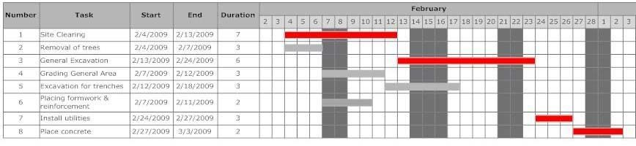

Class Exercise

Gantt Chart

Summary

□ Critical Path Analysis is an effective and powerful method of assessing:

☺ Tasks which must be carried out

☺ Where parallel activity can be carried out

☺ The shortest time in which a project can be completed

☺ Resources needed to achieve a project

☺ The sequence of activities, scheduling, and timings involved

☺ Task priorities

References

* Fondahl, John W., *“Non-Computer Approach to the Critical Path Method for the Construction Industry”,* Report #9, Stanford University, 1961
* Fondahl, John W. “The History of Modern Project Management – Precedence Diagramming Methods: Origins and Early Development”. *Project Management Journal*. Volume XVIII. No. 2. June 1987.
* Hendrickson, Chris & Au, Tung, *Project Management for Construction*, Prentice Hall, 1989
* Weber, Sandra C., *Scheduling Construction Projects: Principles and Practices*, Prentice Hall, 2005

Questions???